January 1st, 2012
Hi
Well, 2011 has gone. For me at least it seems to have gone very quickly. We now need to remember to date mail, etc, with 2012. As usual I slept through the transition; nothing special. Why countries/cities spend millions of dollars on fireworks shows, I don't know!Temperatures at the moment are quite nice though it was the coldest Christmas day for 27 years.
A bit tired so decided to have a break from exercise this past week. I began again yesterday with the run. The weather was fine, cool and dry; good running conditions. I ran from CU across the river, up the hill along to Kowloon Peak then to Shatin and back to CU. Times for this route have averaged about 3 hours and I did not want to run for so long, so thought of finishing at Shatin, which I had done a few years ago. However, it felt reasonably good (except the last 30 min, which is a flat run along the river side, and always tough) so I did the whole route. But at 3 h 9 min (the same overall time as last year), it was 16 mins off my best. I was quite tired in the afternoon however. I am thinking that a maximum of about 2 ½ hours may be more suited to my runs now.
The USS Carl Vinson and a support group arrived in HK the other day for a 3-day visit.
Somehow on Tuesday I hurt my right upper arm. How it happened I have no idea as I was not doing any exercise. By Thursday night it had gone. It was not very troublesome except when trying to turn over in bed; I did not realise just how much the arms seem to be used to do this!
I told you about the temporary ban on live chicken imports from China. Well, this has been extended for certain areas of Guangdong following the death on Friday of a man in Shenzhen from bird flu. In HK, the mainland's liaison office became extremely annoyed the other day when the results of a survey that found that locals identified more strongly as Hongkongers than as Chinese citizens! For more, here is a SCMP report:
http://topics.scmp.com/news/hk-news-watch/article/Beijing-envoy-criticises-HKU-poll
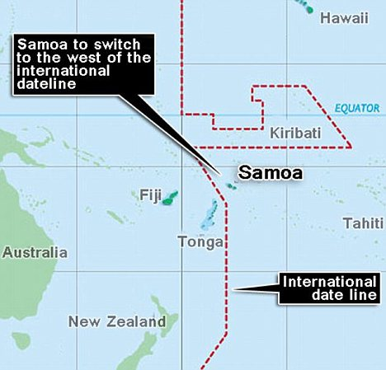
I mentioned a couple of years ago that (Western) Samoa switched from driving on the right to driving on the left because many of the vehicles they buy are from Australia and NZ. Well, the are at it again. On Thursday at midnight, they switched time zones to be same as NZ and Australia which are their main trading partners. This is only possible as they are very close to the International Date Line. The new date line is approximately as I have shown in black on the map. In 1892, the US had persuaded them to be in the US time zone (similar to Hawaii) but that means they were losing one or two days of business every week with Aus and NZ, e.g. when it was Friday (a workday) in Samoa it was Saturday (non-work day) in Aus and NZ, and the other way round for Sunday in Samoa. So at midnight on Thursday, instead of becoming Friday, it became Saturday. However, I don't think the there was a change in time in American Samoa (to the east). I wonder what happens to people whose birthday was on the Friday that disappeared? - maybe they will stay the same age for another year. Incidentally, on a TV report about the time change, there was a video clip of Samoa with vehicles driving on the right! So they were showing a very old clip!!
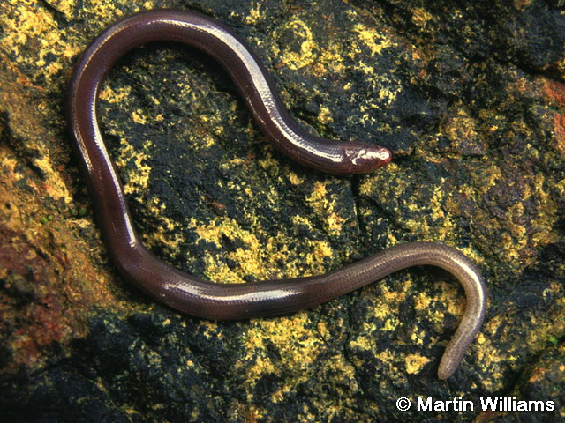
Back to HK. The government will probably be going to a lot of extra expense when it builds an incinerator on a small island near Cheung Chau Island in order to protect a rare lizard. It is only found in three or four places in the world, one of which is this island. Although a lizard, it looks like a worm, as it is essentially legless - see picture. If you are interested, you can learn more about the lizard at:
http://www0.hku.hk/ecology/hkreptiles/lizard/Dibamus_bogadeki.html
For those of you who are medically inclined there was an interesting report the other day of how scientists at Cambridge U are trying to get stem cells in the brain (where there are many) to help MS victims. They are hoping to get the stem cells to create new myelin sheaves around the brain cells to replace those that have been destroyed/lost.
That’s about it for now.
Cheers

